**LIVERPOOL CENTURY**

**BRIAN ROONEY MEMORIAL 10 MILE TT**

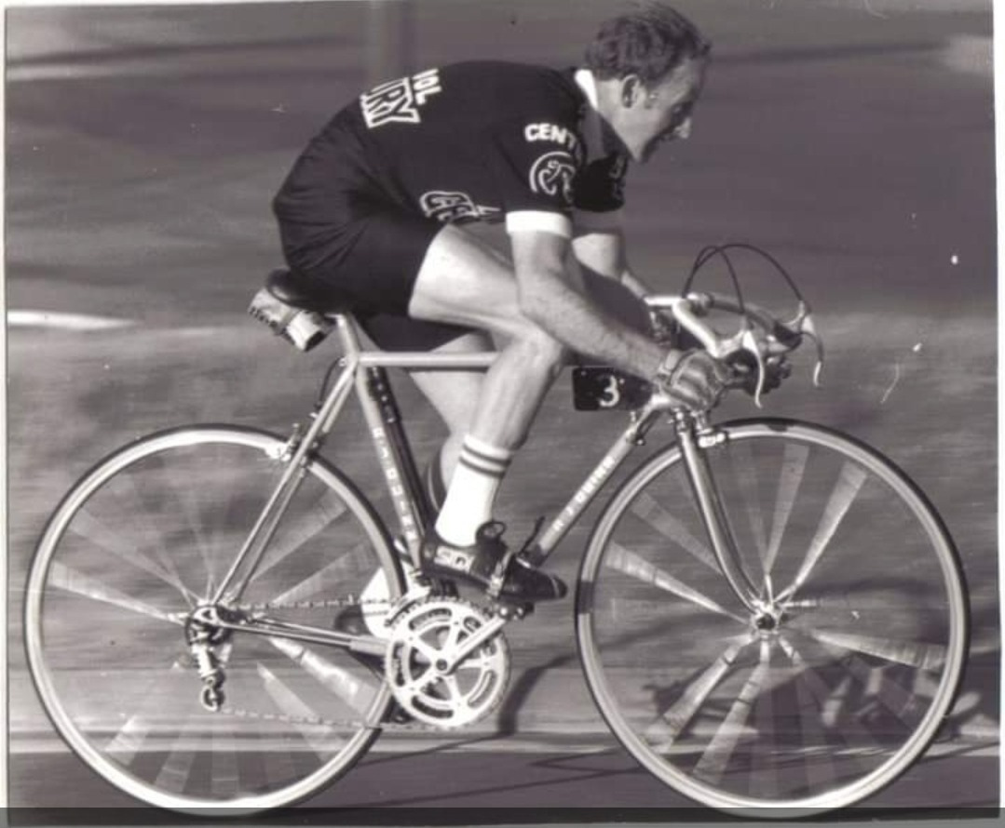

**RESULTS**

1.KIERAN MORRIS

2.ALASTAIR RIBBANDS

3.BRADLEY MURPHY

**LADIES**

1.SAM HOWARD

2.SOPHIE ROTHERAM

3.KATIE LAWSON

**VETS**

1. ALASTAIR RIBBANDS

2.BRADLEY MURPHY

3.MARK PARSONS

**ROAD BIKE**

1.JOE ALLEN

2.TIM MARSHALL

3.RICHARD POOLEY

**JUNIOR**

1.LIAM HEWITT

2.DANIEL JONES

3.LIAM MILLS